**Homework 3 Report**

-The code starts with importing matplotlib, numpy, pandas, and seaborn.

-The code takes the image data and label data from excel, the image data is divided to train_set and test_set. The label data is first converted to int as “A”=1, “B”=2, “C”=3, “D”=4, “E”=5 and divided to train_truth and test_truth.

-Parameter estimation is done by:

Priors are calculated by the number of chosen class is divided the total number of all classes.

Means are calculated by taking the mean of every set that corresponds to the chosen class.

-The general shape of every class is plotted by using heatmap. The mean of every class is taken and reshaped to 20x16 matrix to be plotted.

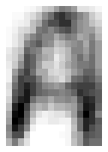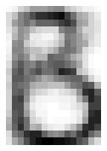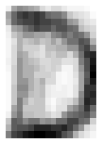

-Score function is implemented as

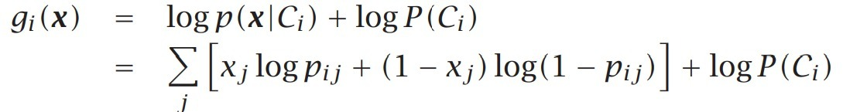

-The confusion matrix is created for training set by using score function.

y_truth 1 2 3 4 5

y_pred

1 25 0 0 0 0

2 0 24 1 0 1

3 0 0 24 0 0

4 0 1 0 25 0

5 0 0 0 0 24

-The confusion matrix is created for test set by using score function.

y_truth 1 2 3 4 5

y_pred

1 7 0 0 0 0

2 0 11 3 2 4

3 0 0 7 0 0

4 7 3 3 12 0

5 0 0 1 0 10